|  |  |  |
| --- | --- | --- |
|  | **Rochester Institute of Technology**  **Golisano College of Computing and Information Sciences**  **School of Interactive Games and Media**  **2145 Golisano Hall – (585) 475-7680** |  |

**Data Structures & Algorithms for Games & Simulation II**

**IGME 309**

**E07: ARBB**

This exercise follows lecture 19C – ARBB

It is meant to help you practice the creation of Axis (Re)Aligned Bounding Boxes.

There is starter code for this project, you will find it under our class repository with the name E07_ARBB but if you want to use your own framework you are welcome to translate the starting code to it.

Once you open the solution you will be presented with the following scene:

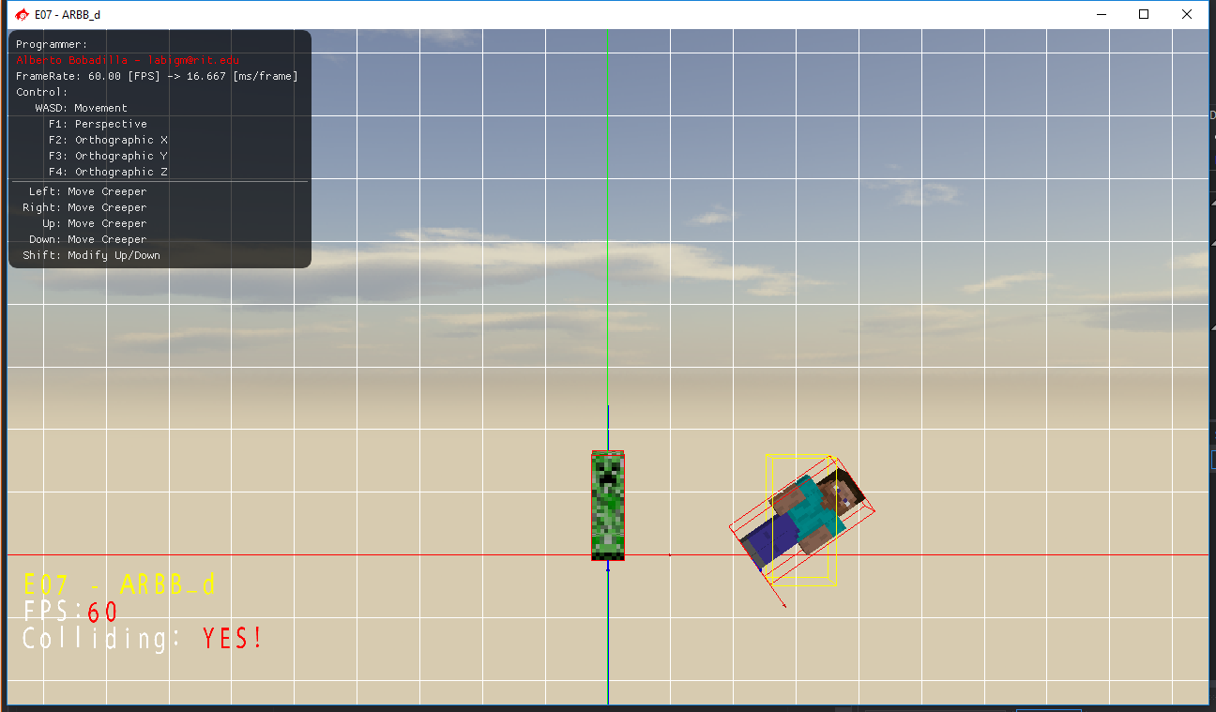

What you need to do for this exercise is create the Axis (Re)aligned Bounding Box in the MyRigidBody class. It need to be coded inside the SetModelMatrix method, it is not necessary to add any helper functions.

Your Scene should look like this once the objects are oriented and the method is implemented:

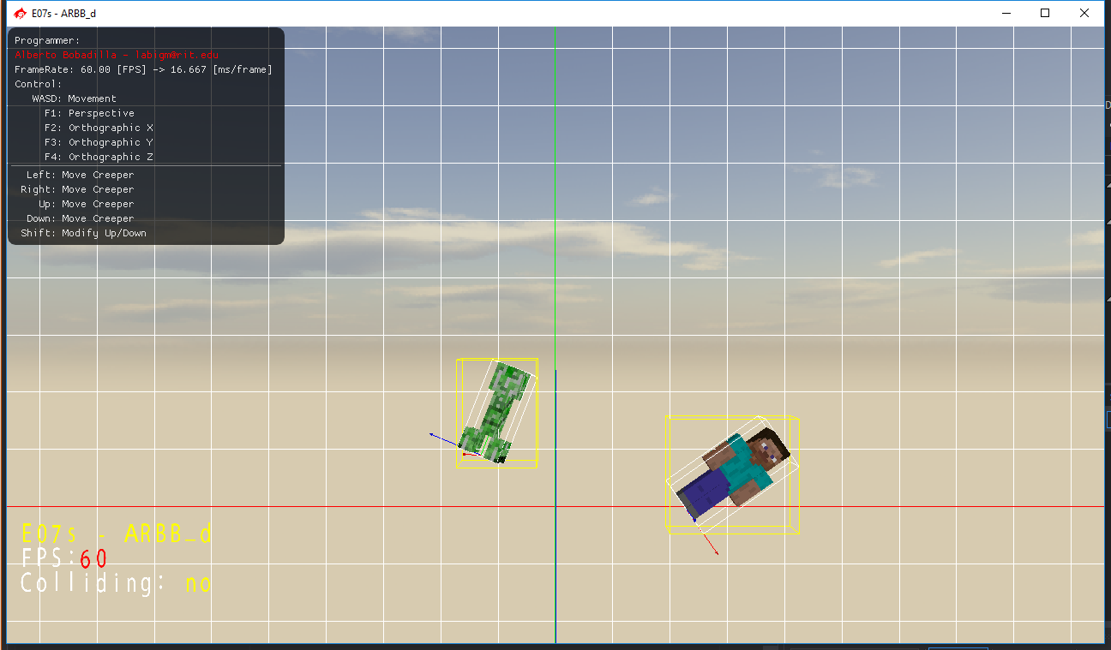

For now we will be ignoring the pre-test of the bounding sphere, so once you have a collision your OBB will change to the color red:

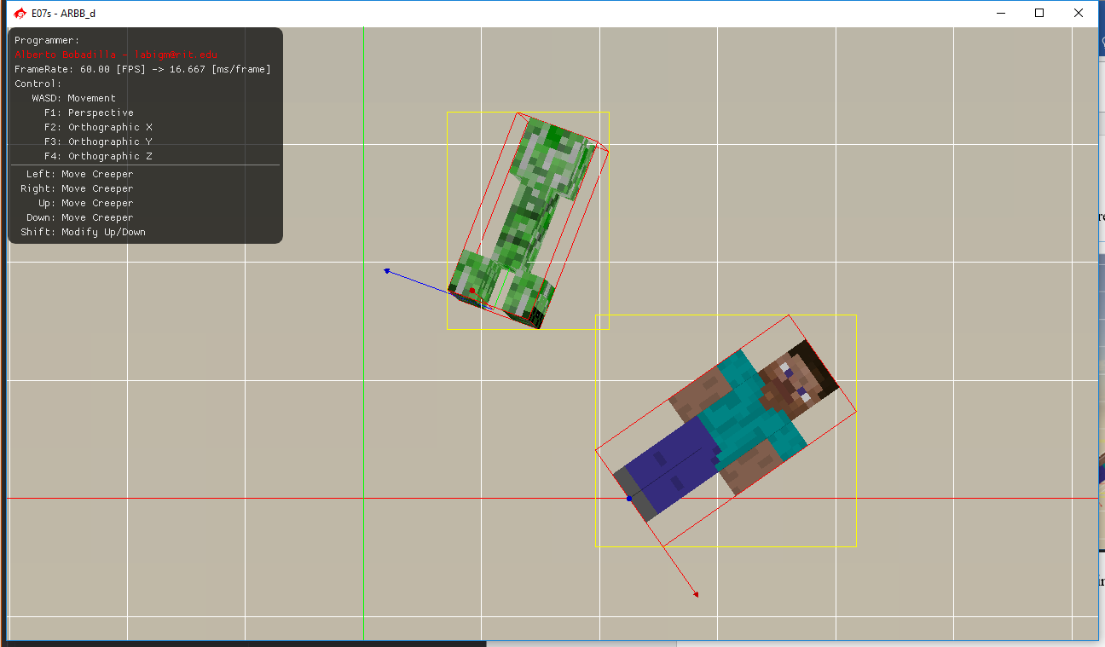

There is an example executable under the _binary folder.

Notes:

As usual, your submission is only a zipped version of the project NOT the whole solution, it should be less than 50 kb total, (unless you are using your own models/textures or your own framework solution). Push your solution to your repository with the comment “**E07 Deliverable**” then zip the project and upload it to the dropbox “**E07 - ARBB**”, in the comments section you need to specify the address of your repository.

Example:

